September 30th-October 4th the ECC will host a Scholastic book fair in the library. Your class will have a scheduled shopping day.

**Book fair shopping hours will be from 9:00 am-2:00 pm**.

**We will not allow shopping during your student’s lunchtime.**

If you are not able to attend with your student, you may send money or set up an eWallet account and the librarian will assist them. Please label bag or envelope with “book fair money” and student’s name.

The book fair will accept cash OR credit cards. NO checks

Below is the schedule for shopping with your student from 9:00 am-2:00 pm

(not during your student’s lunch time)

**Monday September 30th**

Morgan, Elwood, Garza, Almaguer

**Tuesday October 1st**

McIntyre, Urbis, Carreon, Duenes, Grimes, Vaughn

**Wednesday October 2nd**

Moore, Azua, Olson, Cooper, Gadberry, Lowry, Arredondo, Ellis

**Thursday October 3rd**

Garcia, Morais, Molina, Zambrano, Krueger, Eckhart

**Friday October 4th**

Ashcraft, Ruiz, Gatton, Hinojosa,

*Set up an eWallet here:*

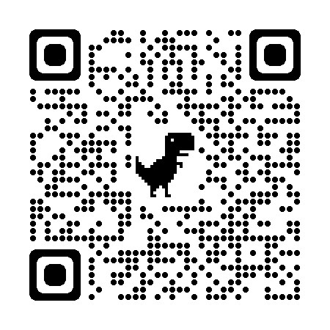

*Make sure you never forget to give your student money on shopping day. You can even add notes for the librarian Example: books only, no pencils or bookmarks*

*Add funds at any time!*

*Make sure you share eWallet with Friends and Family so they can add funds!*